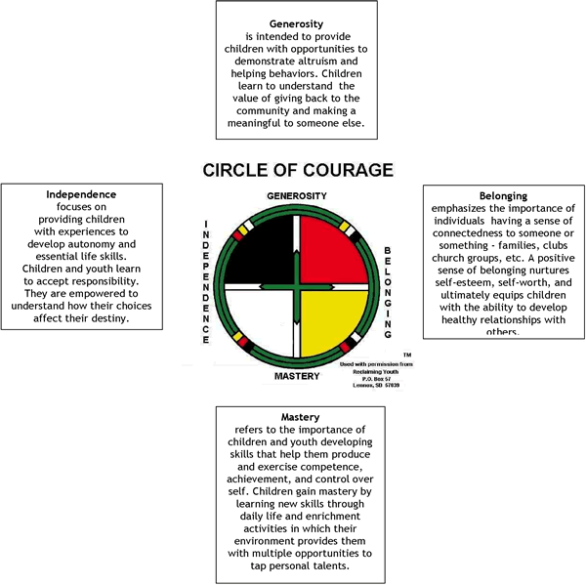

Spirit of Belonging  Maslow’s theory of human needs suggests that a sense of belonging must be attained before self-esteem and self-actualization can be realized. As children are drawn into the circle in the Spirit of Belonging, a relationship is established which is based upon mutual trust and respect. This provides the motivation to live with “a minimum of friction and maximum of goodwill” (Brendtro et al., 1990). The ultimate test of this kinship is behavior. You really belong when you act like you belong!  Spirit of Belonging Distorted Spirit of Belonging Broken Spirit of Belonging  Attached Gang Loyalty Unattached  Loving Craves Affection Guarded  Friendly Craves Acceptance Rejected  Intimate Promiscuous Lonely  Gregarious Cult Vulnerable Isolated  Trusting Overly Dependent Distrustful  Mending a Broken Spirit  - Create a cohesive classroom environment where each child can feel like an important member.  - Give positive encouragement.  - Recognize individuality and creative talents.  - Make sure teacher/caregiver expectations are very clear so children understand classroom expectations.  - Be specific when reinforcing a child’s positive behavior.  - With discipline and behavior, focus on the deed and not the doer. | Spirit of Mastery  Native education strives to develop cognitive, physical, social and spiritual competence. This holistic view of learning recognizes that all students can learn and each student must be given the opportunity to demonstrate competence in all areas. Without opportunities for success, children will tend to express their frustration and lack of self-worth through inappropriate behaviors. Learning that is somehow connected to the everyday life of the child and the opportunities for sharing provide very powerful intrinsic motivators. In the Spirit of Mastery, success becomes “a possession of the many, not of the privileged few” (Brendtro et al., 1990).  Spirit of Mastery Distorted Spirit of Mastery Broken Spirit of Mastery  Achiever Overachiever Non-achiever  Successful Arrogant Failure Oriented  Creative Risk Seeker Avoids Risks  Problem Solver Cheater Fears Challenges  Motivated Workaholic Unmotivated  Persistent Perseverative Gives Up Easily  Competent Delinquent Skill Inadequate  Mending a Broken Spirit  - Connect classroom experiences with the children’s personal lives.  - Make sure each child experiences success in something.  - Help children set realistic goals.  - Teach problem solving strategies.  - Teach children to solve problems through collaboration.  - Encourage taking on challenging tasks.  - Consider alternative ways of knowing when designing activities.
Spirit of Independence  Child empowerment is required to foster the belief that a child is in control of the learning process. This sense of autonomy is a powerful intrinsic motivator. In Native American culture the internal locus of control must be balanced by social controls. Children first need to be dependent, learning to respect and value the wisdom of “elders”. Modeling provides a basic framework, which can be adjusted by each child to adapt to his/her particular learning style and multiple intelligences.  Spirit of Independence Distorted Spirit of Independence Broken Spirit of Independence  Autonomous Dictatorial Submissive  Confident Reckless/Macho Lacks Confidence  Responsible Sexual Prowess Irresponsible  Inner Control Manipulative Helplessness  Self-Discipline Rebellious Undisciplined  Leadership Defies Authority Easily Led  Mending a Broken Spirit  - Model decision-making and assist children in developing their own framework.  - Give choices for activities to recognize multiple intelligence development.  - Involve children in participatory decision-making.  - Encourage children how to engage as learners.  - Help children develop internal controls—an inner self-discipline for student empowerment.  - Teach alternative behaviors to improve personal control.  - Model and teach personal responsibility.  - Let children face the consequences of their behavior  Reference:  Brendtro, L., Brokenleg, M., & Van Bockern, S. (1990). Reclaiming youth at risk: Our hope for the future. New Jersey: National Educational Services. | Spirit of Generosity  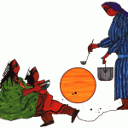  The highest virtues in Native culture are generosity and unselfishness. Self-esteem and self-worth are greatly increased by learning to help others. There is a responsibility to consider the welfare of everyone in the community. In a classroom or community site, peer tutoring and cooperative learning groups allow children to share their talents with others. There is a feeling of pride and joy that is experienced by helping others. Without opportunities to share their talents, students cannot become caring, responsible adults. The help given must be genuine and not equated with personal gain. Children should be encouraged to get involved in the community, and school, through a variety of service projects.  Spirit of Generosity Distorted Spirit of Generosity Broken Spirit of Generosity  Altruistic Noblesse Oblige Selfish  Caring Over involved Affectionless  Sharing Plays Martyr Narcissistic  Loyal Co-dependency Disloyal  Empathic Over involvement Hardened  Pro-social Servitude Anti-social  Supportive Bondage Exploitative  Mending a Broken Spirit  - Foster cooperative interpersonal relationships.  - Encourage child to be a good listener and a good communicator.  - Encourage children to express their opinions.  - Understand that children may express themselves in ways that may help or hurt themselves or others.
Let’s Practice!
1. Write down observations about a situation (real or imagined) in which a student is exhibiting a behaviour or behaviours that need to be modified.
______________________________________________________________________________________________________________________________________________________________________________________________________________________________________________________________________________________________________________________________________________________________________________________________________________________________________________________________________________________________________________________________
2. Share your observations with your partner or partners. Write down any patterns that you see.
_________________________________________________________________________________________________________________________________________________________________________________________________________________________________________________________________________________________________________________________________________________________________________________________________________________________________________
3. Use the check list (located on the next page) to help you to identify which of the four quadrants on the circle of courage are most related to the behaviours. Make notes in the space provided.
____________________________________________________________________________________________________________________________________________________________________________________________________________________________________________________________________________________________________________________________________________________
4. Brainstorm ideas for in-class supports. The “Mending a Broken Spirit” sections on pages one and two will give you some ideas.
_________________________________________________________________________________________________________________________________________________________________________________________________________________________________________________________________________________________________________________________________________________________________________________________________________________________________________
5. Brainstorm Ideas for external supports
_________________________________________________________________________________________________________________________________________________________________________________________________________________________________________________________________________________________________________________________________________________________________________________________________________________________________________

Belonging
Normal | Distorted | Absent
Attached | Gang Loyalty | Unattached
Loving | Craves Affection | Guarded
Friendly | Craves Acceptance | Rejected
Intimate | Promiscuous | Lonely
Gregarious | Clinging | Aloof
Cooperative | Easily Misled | Isolated
Trusting | Overly Dependent | Distrustful
Mastery
Normal | Distorted | Absent
Achiever | Overachiever | Non-achiever
Successful | Arrogant | Failure Oriented
Creative | Risk-seeker | Avoids Risks
Problem Solver | Cheater | Fears Challenges
Motivated | Workaholic | Unmotivated
Persistent | Compulsive | Gives Up Easily
Competent | Delinquent Skill | Inadequate
Independence
Normal | Distorted | Absent
Autonomous | Dictatorial | Submissive
Confident | Reckless/Macho | Lacks Confidence
Assertive | Bullies Others | Inferiority
Responsible | Power Struggles | Irresponsible
Inner Control | Manipulative | Helplessness
Self-Discipline | Rebellious | Undisciplined
Leadership | Defies Authority | Easily Led
Generosity
Normal | Distorted | Absent
Altruistic | Noblesse Oblige | Selfishness
Caring | Indulgent | Affectionless
Sharing | Plays Martyr | Narcissistic
Loyal | Co-Dependent | Disloyal
Empathic | Over-involved | Hardened
Prosocial | Servitude | Antisocial
Supportive | Bondage | Exploitative

