Sight Word List
Top 160 words in order of frequency
- the | - of | - to | - and | - a
- in | - is | - it | - you | - that
- he | - was | - for | - on | - are
- with | - as | - I | - his | - they
- be | - at | - one | - have | - this
- from | - or | - had | - by | - hot
- but | - some | - what | - there | - we
- can | - out | - other | - were | - all
- your | - when | - up | - use | - word
- how | - said | - an | - each | - she
- which | - do | - their | - time | - if
- will | - way | - about | - many | - then
- them | - would | - write | - like | - so
- these | - her | - long | - make | - thing
- see | - him | - two | - has | - look
- more | - day | - could | - go | - come
- did | - my | - sound | - no | - most
- number | - who | - over | - know | - water
- than | - call | - first | - people | - may
- down | - side | - been | - now | - find
- any | - new | - work | - part | - take
- get | - place | - made | - live | - where
- after | - back | - little | - only | - round
- man | - year | - came | - show | - every
- good | - me | - give | - our | - under
- name | - very | - through | - just | - form
- much | - great | - think | - say | - help
- low | - line | - before | - turn | - cause
- same | - mean | - differ | - move | - right
- boy | - old | - too | - does | - tell
- sentence | - set | - three | - want | - air
- well | - also | - play | - small | - end
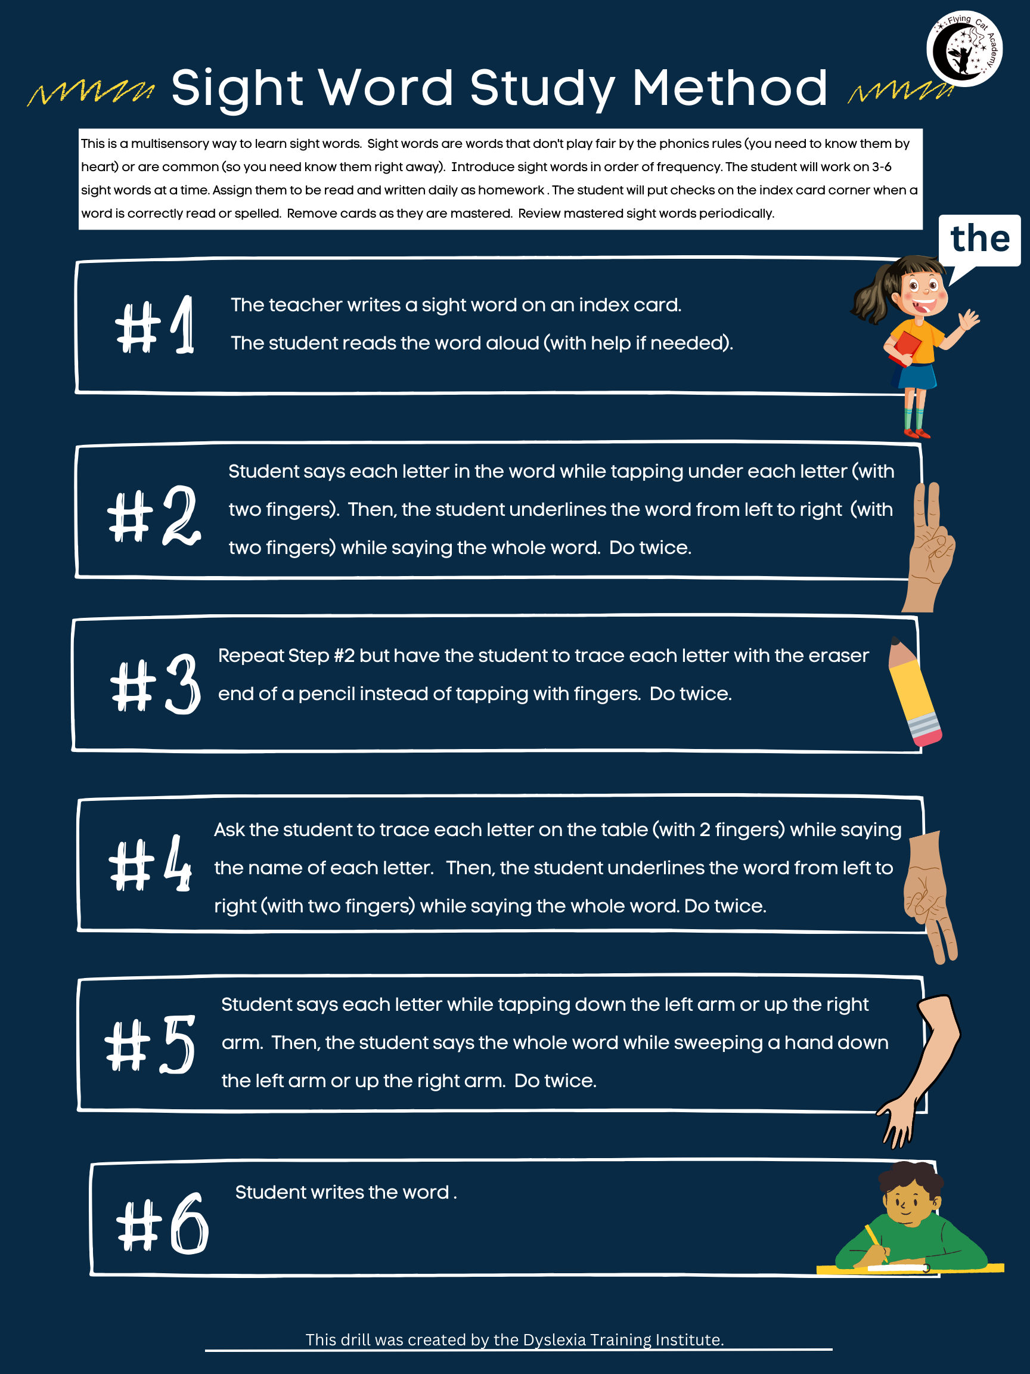
Blending Drill
Materials: letter cards
Purpose: to develop automaticity with blending
Instructions: Place down letter tiles to form real and nonsense words. Ask the student to “tap it” and “say it.” This means that they say each sound in the word while tapping under each grapheme with two fingers. Then they read the whole word. The teach will change the word by adding a new card and the student will do the “tap it, say it” process again.

- Prior to the start of the drill the teacher makes a word chain. Here is an example: mat, cat, bat, sat, sad, sap, map, mop, mip, nip
- Put 3 letter cards down M-A-T. At the start of the reading remediation, you will begin by using only VC and CVC words.
- Ask the student questions. For example, you can point to a letter and ask if it is consonant or a vowel. You could also ask the student to identify the syllable type if you have previously taught that concept.
- Ask the student to tap under each letter while saying the sound each card makes. Then, ask them to draw a line under the word with two fingers while blending the sounds to read the whole word. Once the student is familiar with the drill you can use a simple prompt the student by saying, “Tap it, say it.”
- Put a new card over top of the first card but keep the second card and third cards the same. Ask the student to repeat the exercise. Keep changing the first letter and then change the last letter, but always keep the middle one the same. Make about 8 real and non-sense words.
- Once the student has developed some proficiency with changing the first sound, then try changing the last letter.
- Once the student has some proficiency with changing the last sound in the word, start changing the middle sound.

Magnetic Letter Tile Reading Drill
Materials: magnetic letters spread in rainbow shape on cookie sheet
Purpose: This is a multisensory method for teaching a student to read a word.
Instructions: The student creates real and nonsense words with magnetic letter tiles. The teacher says each sound and the student brings the correct letter tiles to the middle of their cookie sheet. They tap and say each sound and then blending the sounds to read words.
Sample Narrative
- Teacher spreads letter tiles - in alphabetical order - in rainbow shape
- Teacher says, “Can you say the sound /s/?”
- Student says the sound.
- Teacher says, “Find the letter that makes the sound /s/”
- The student finds the correct and pulls it into workspace.
- Repeat steps 2-6 for the following sounds: /a/ and /p/
- Teacher says, “Using two fingers, can you tap each tile and say each sound?”
- Teacher asks the student if he/she can say the word.
- Teacher asks the student to use the word in a sentence

Blocking Strategies (Use these strategies if a student is struggling.)
- Use or make a keyword: Teacher helps the student to think of a keyword for the letter or sound. If the student does not already have a keyword for the sound, the student will draw a picture of this keyword on the back of the correct card in their letter card pack and write the word under the picture. The teacher will provide the spelling for the word if needed.
- Teacher asks the student to say the keyword for the letter.
- Teacher asks the student, “What sound does that letter make?”
- If the student answers incorrectly, the teacher will compare the two sounds for the student by saying, “Listen to these two sounds and tell me if they are the same or not. The student should be able to hear that the two sounds are not the same. If the student still seems unsure, the teacher will ask the student to place two hands on their throat and will use the oral-kinesthetic methods to help the student feel the difference between the sounds.
- Teacher says, “What letter makes the (say the sound for the letter that the student should have selected) sound?
- Student will say the sound and letter and pull down the correct letter tile.

Magnetic Letter Tile Spelling Drill
Materials: magnetic letters in alphabetical order (rainbow shape) on cookie sheet
Purpose: This is a multisensory method for teaching a student to spell a word.
Instructions: The student creates real words with magnetic letter tiles. The teacher says a whole word. Then the student brings the correct letter tiles to the middle of their cookie sheet. They tap and say each sound and then blending the sounds to read words.
Sample Narrative
- Teacher says, “We are going to work with the word tip. Can you repeat the word?”
- Student says, “Tip.”
- Teacher says, “Can you use the word cup in a sentence?” (You are doing this so that you are certain that the student knows what word he/she is going to spell.)
- Teacher says, “What is the first sound that you hear in tip?”
- The student says the sound, finds the correct letter tile, and pulls it down into workspace.
- Teacher says, “What is the next sound that you hear in the word tip?”
- The student says the sound, finds the correct letter tile and pulls it into the space in front of him/her/them.
- Teacher says, “What is the last sound that you hear in the word tip?”
- Teacher says, “Using two fingers, can you tap each tile and say each sound?”
- Teacher asks the student to read the word.
Blocking Strategies (Use these strategies if a student is struggling.)
- Use or make a keyword: Teacher helps the student to think of a keyword for the letter or sound. If the student does not already have a keyword for the sound, the student will draw a picture of this keyword on the back of the correct card in their letter card pack and write the word under the picture. The teacher will provide the spelling for the word if needed.
- Teacher asks the student to say the keyword for the letter.
- Teacher asks the student, “What sound does that letter make?”
- If the student answers incorrectly, the teacher will compare the two sounds for the student by saying, “Listen to these two sounds and tell me if they are the same or not. The student should be able to hear that the two sounds are not the same. If the student still seems unsure, the teacher will ask the student to place two hands on their throat and will use the oral-kinesthetic methods to help the student feel the difference between the sounds.
- Teacher says, “What letter makes the (say the sound for the letter that the student should have selected) sound?
- Student will say the sound and letter and pull down the correct letter tile.
Short Vowel Drill
Materials: magnetic letter tiles, 5 pictures (apple, eddy, itchy, olive, up), key word phrase sheet (choose either “Sad Ed did not run” or “Fat Ed is not up.”
Purpose: This is a multisensory technique for assisting the student with learning the phonemes of the short vowel sounds. Key words: a - apple, e - eddie, i - itchy, o - olive, u - up.
Instructions:
1. Using two fingers, the student will trace a picture, while saying the keyword at the same time. Then, the student will underline the keyword (from left to right) and say the sound of the target phoneme. Repeat four more times.
2. The student will use the other pictures and do the same tracing/speaking/underlining activity explained in Step #1 for the other short vowel sounds.
3. The teacher will hold up magnetic letter tile of the short vowels and ask the student to say the phonemes.
4. The student will choose a keyword sentence from two options. The teacher and student will say the sentence in a way that stretches out the vowel sounds in each word. Repeat once.

Sample Narrative
1. The student says, “Apple,” in a way that draws out the short ‘a’ sound (while tracing the picture with two fingers). When the tracing is finished the student will use two fingers to draw a straight line from left to right under the picture and say, /a/. The student will repeat this activity 4 more times.
2. The student will use the other pictures and do the same tracing/speaking/underlining activity explained in Step #1 for the other short vowel sounds.
3. There is also a sentence for the student to practice hearing the short vowel sounds in a sentence. The sentence is, "Fat Ed is not up." (It contains all the short vowel sounds.) Ask the student to read the sentence slowly. The purpose for this sentence is to train the brain to "hear" (process and build the neural pathways) the short vowel sounds. Have the student practice this sentence 2 times in a row.
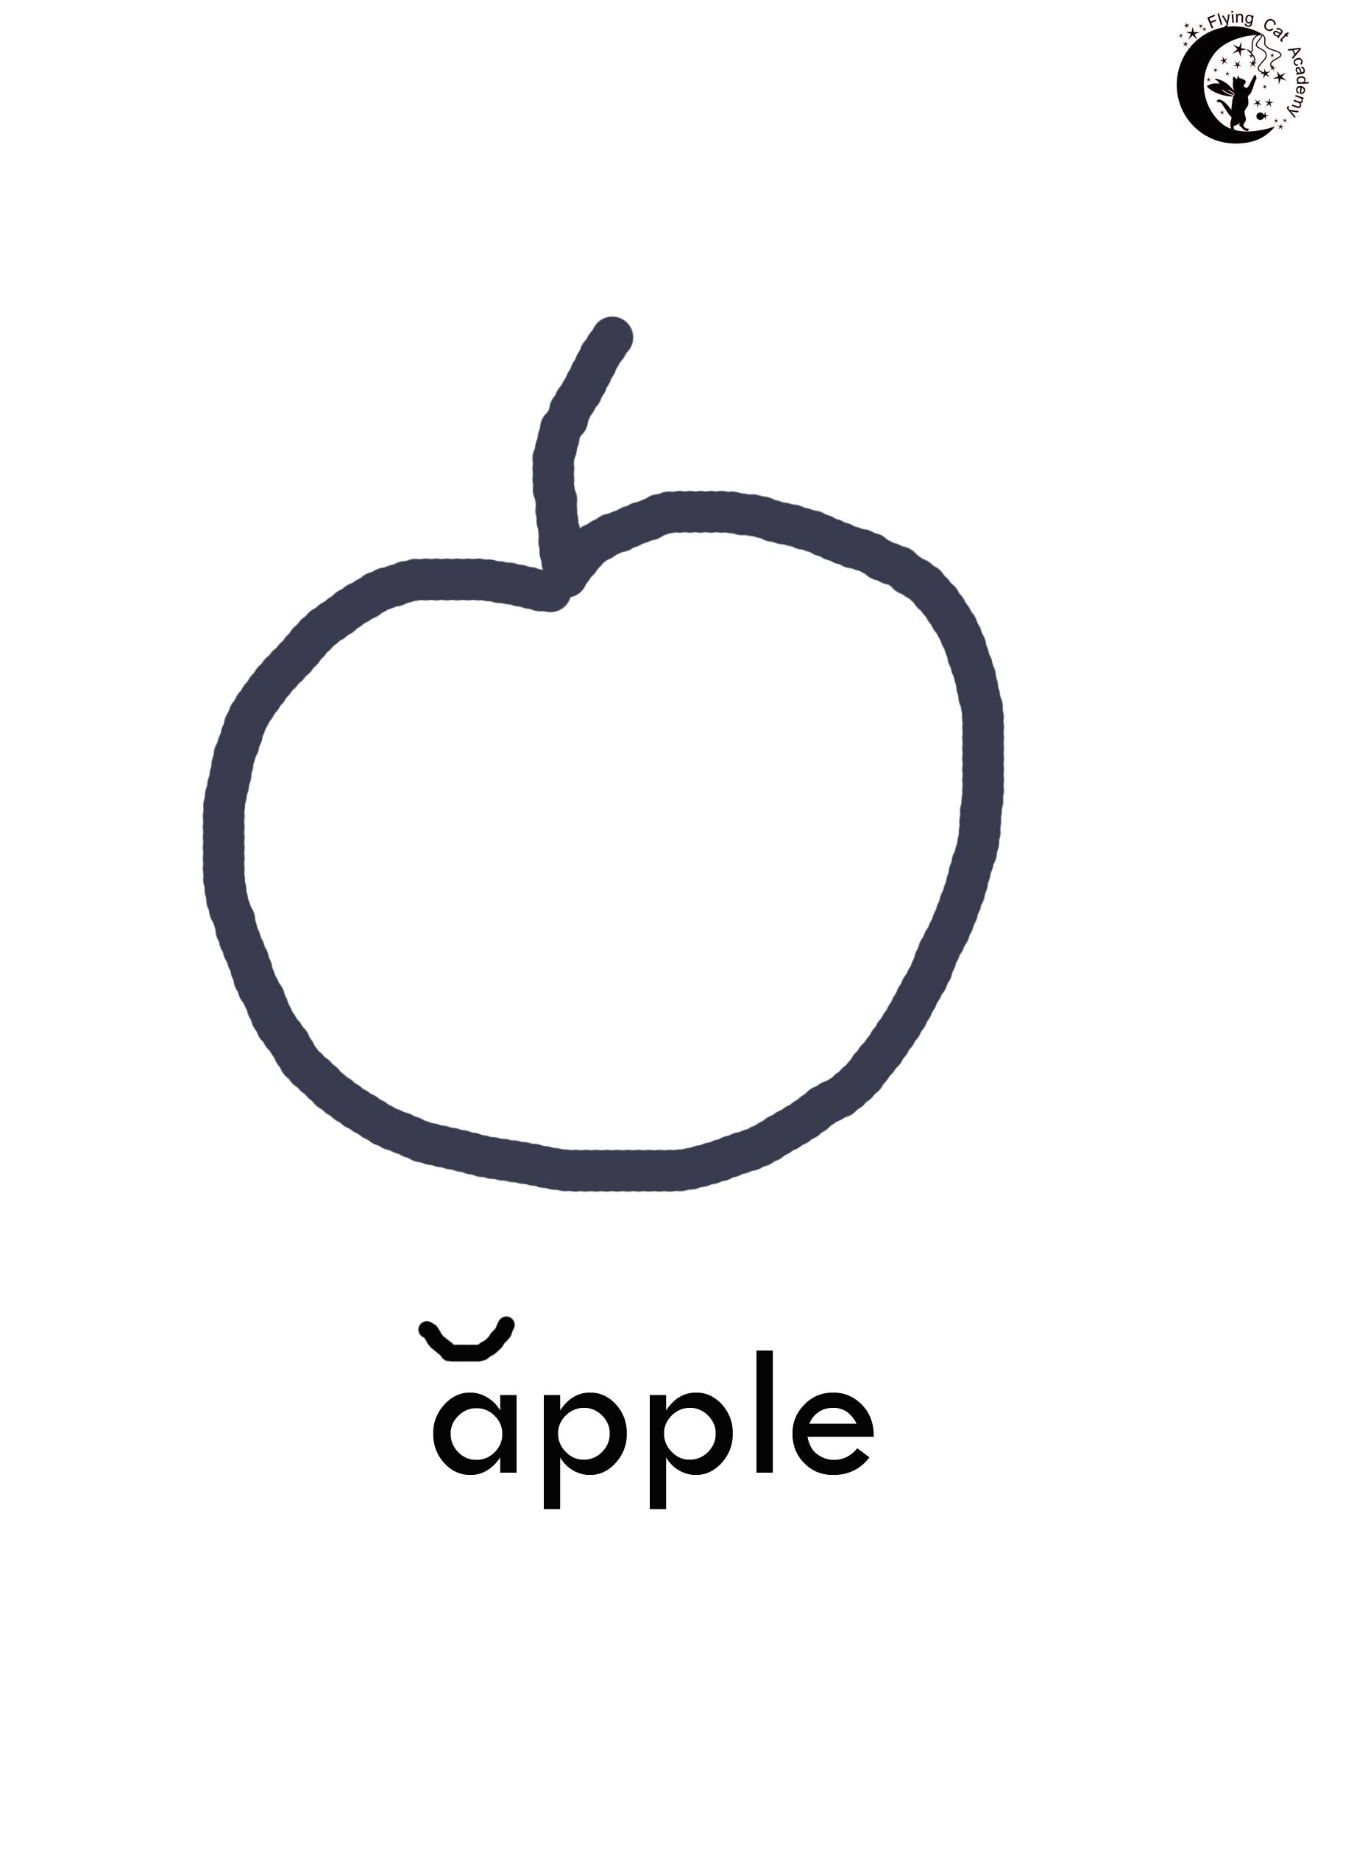
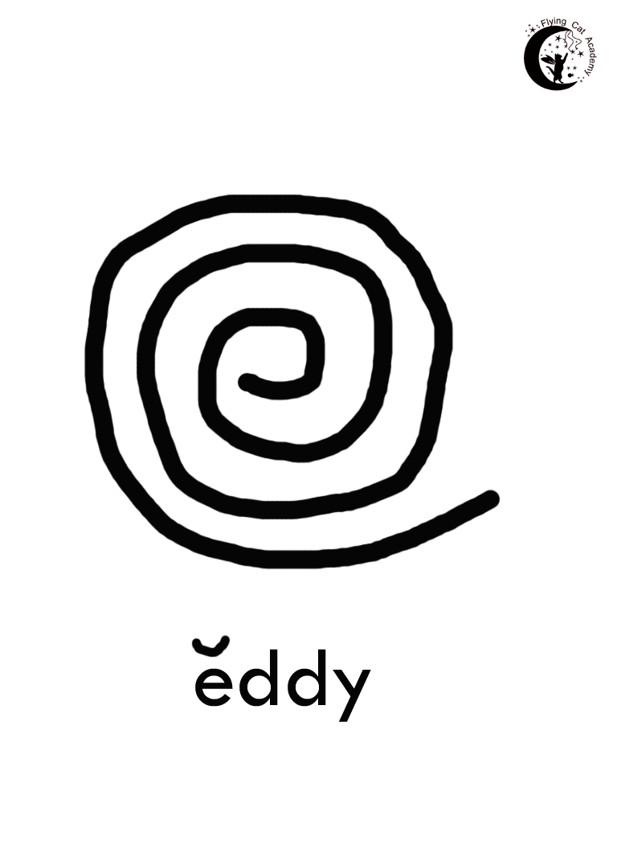
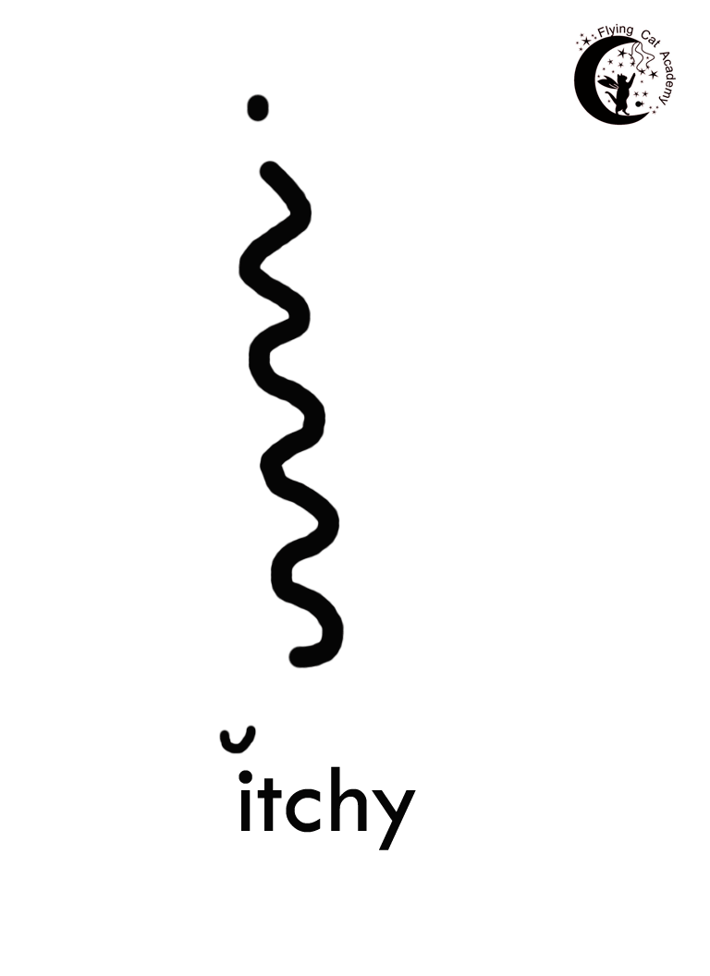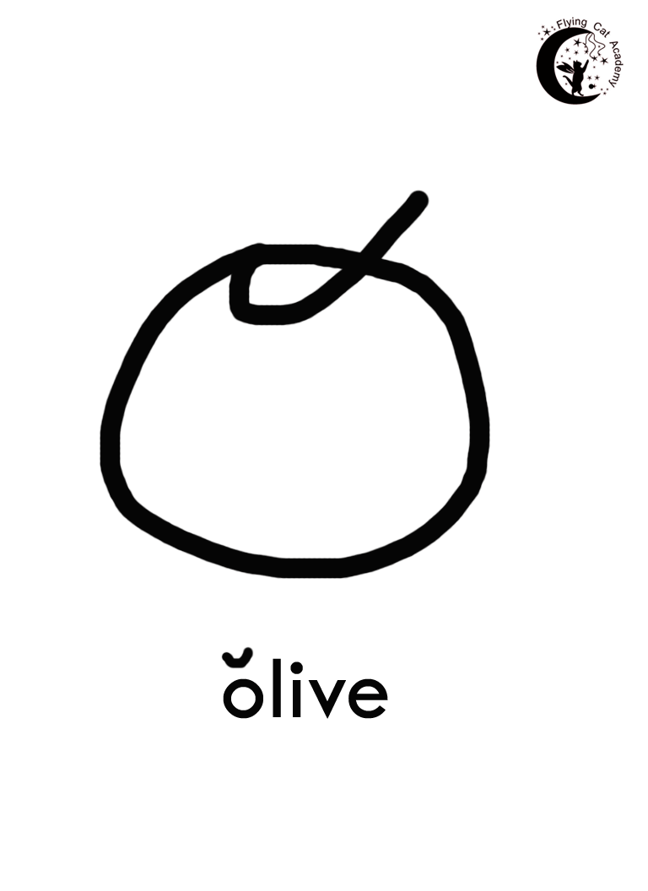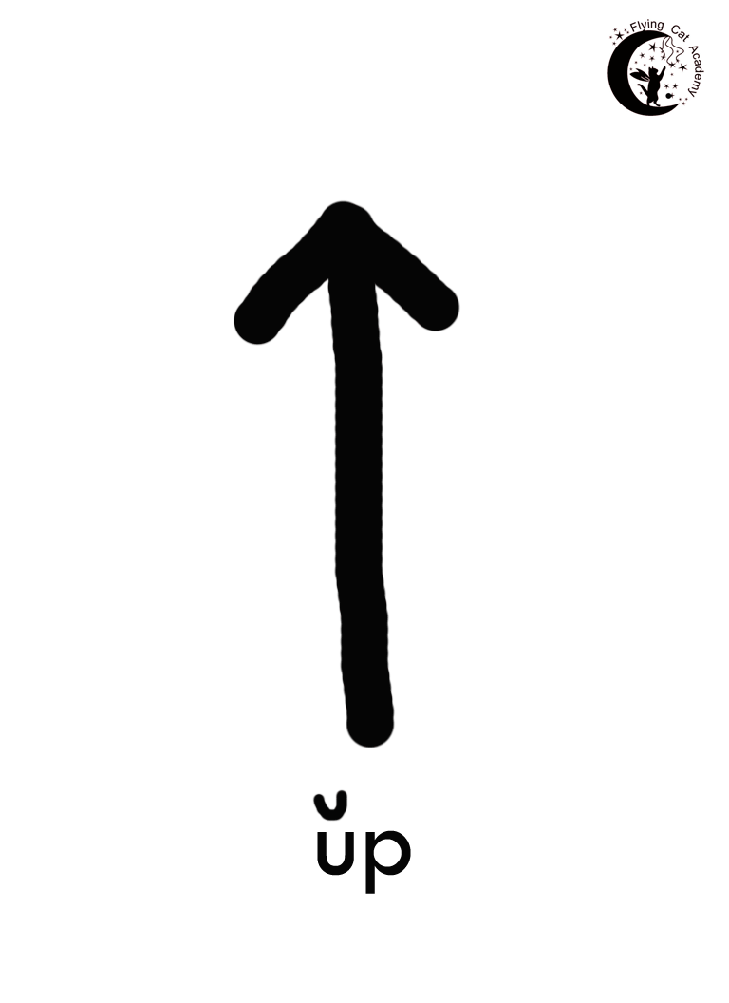

Sad Ed did not run.

Fat Ed is not up.

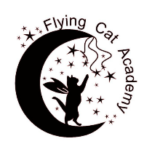
New Phoneme/Grapheme Kinesthetic Discovery
Step 3: Oral-kinesthetic Discovery
- Explain that the student is going to explore what is happening in the throat and mouth when pronouncing a target sound.
- Ask student to name the different parts involved in making a sound: vocal chords, lips, tongue, jaw.
- ask student to put their hands on their neck
- tell student that they are going compare how three different sounds feel (one of the sounds will be the target sound)
- make the first sound for the student
- ask student to make the first sound
- ask student to say what they are feeling
- repeat step 5-7 for the other two sounds
- ask student to comment on differences between the 3 sounds
- do exercise again and explain what student should be feeling.
- Recap the main points for making the target sound.
Materials: word list, index cards, pencil crayons
Purpose: This is a multisensory approach to teaching a new phoneme/grapheme.
Step 1: Auditory Discovery
- ask the student to listen carefully and to look at the teacher’s lips and mouth
- call and repeat 8 words that have /p/ in different parts of it (either at beginning, middle or end).
- discuss non-sense words.
- ask the student to name the sound they are hearing in every word
- restate the sound

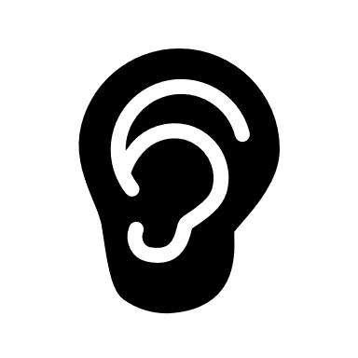
auditory modality
visual modality
manual-kinesthetic modality
oral-kinesthetic modality
The drill was created by Dr. Vincent Goetry and adapted by the Flying Cat Academy.
Step 4: Manual-Kinesthetic Discovery
- explain that the task is to make a letter card
- shows a card with target sound on it and make the sound
- ask student to repeat sound
- give blank index card to student
- ask student to think of words that have the target sound in them. Ask if the sound ever changes or if it is always the same.
- Ask student to write the small letter for the target sound in the center of the card and a “1” to show that there is only one sound for this letter. Ask student to make a capital letter in bottom left of the card.
- on back of card, student will make one picture of something that begins with the target letter. The teacher should tell them how to spell the word if needed.

Step 2: Visual Discovery
- give student a list of words that they just heard
- ask student to circle the letter which corresponds to the target sound with their favourite colour. Tell them to watch out because you’re not asking them to read the words – only asking them to circle the letter
- demonstrate circling a target letter
- reads the words while student circles the letters

